COS 301 CAPSTONE PROJECT

Defendr User Manual

Advance & Dark nITes

Ruslynn Appana

Jeandre Botha

Muhammed Ismail Carrim

Sisa Khoza

Christiaan Opperman



Table of Contents

1. Introduction 3

1.1. System Overview 3

1.2. System Configuration 3

1.3. Installation 4

2. Getting Started 4

2.1. Signing in 4

2.2. Registering 5

3. Using the System 6

3.1. Exploring the home window 6

3.3. User Management 8

3.4. Changing user details 9

3.5. IP blacklisting 10

3.6. IP Whitelisting 11

3.7. Viewing traffic logs 12

3.8. Viewing System metrics 13

3.8.1. Sign-in 13

3.8.2. Home Dashboard 13

3.8.3. - A) New dashboard 14

3.8.4. - C) Explore 14

3.8.5. - D) Alerting 15

3.8.6. - E) Configuration 15

3.8.7. - F) Server Admin 16

3.8.8. - G) Defendr – System Load 16

3.8.9. - G) Defendr – Software Load 17

3.9. Backends and Load balancing 18

3.9.1. Backends Interface 18

3.9.2. Preparig service backends 19

3.9.3. Adding service backends 19

4. Troubleshooting 21

4.1. Missing bpf maps 21

4.2. Grafana is not showing any data 21

4.3. Interface failures 25

4.3.1. Failure to Sign in 25

4.3.2. Failure to open certain windows 25

4.3.3. Failure to add IP address to black list: 25

4.3.4. Failure to add new User: 26

# Introduction

## System Overview

The purpose of this system is to protect third party applications from malicious users. The system implements this by detecting DDOS attacks and dropping the packets that are associated with an attack. It also provides load balancing features to control the load for each pool of resources that it is connected to.

The user interacts with the system via an intuitive graphical user interface where the user can to add and remove IP addresses to a white- and blacklist, see packets that traversed the system, view metrics (such as drop rates, packet sizes etc.) and remove and add back-end applications.

## System Configuration

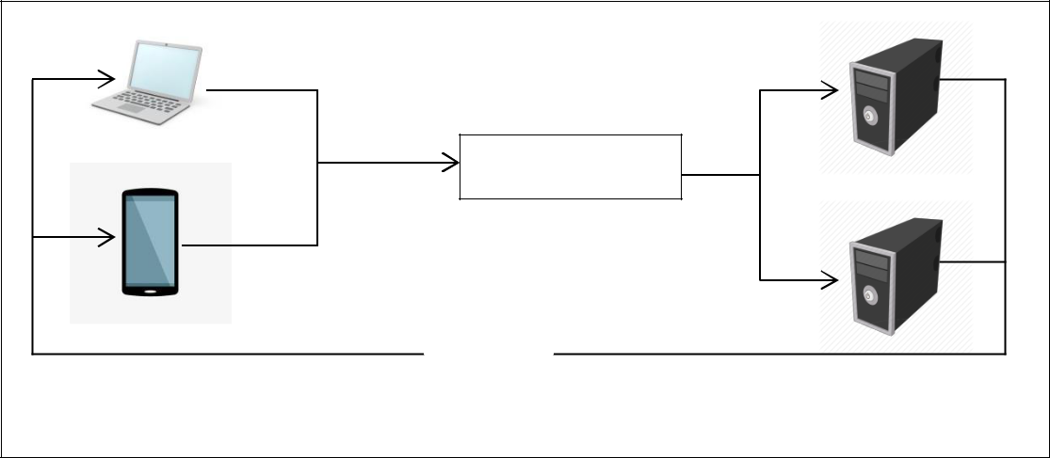

|  |  |  |
| --- | --- | --- |
|  | Request |  |
|  | Defendr Server |  |
|  | Request |  |
|  | Forward |  |
|  | Answer |  |
| Third party’s client | Servers |  |
|  |  |

There are three main components in this system, namely: servers on which back-end applications run, normal devices that the client uses to connect to the third party application and a server on which Defendr executes. The servers on which back-end applications run and the normal devices that the client uses to connect to the third party application is beyond the scope of this user manual. Defendr runs on a server that intercepts the packages after they have left the third party’s client , but before they reach the application.

# Installation

1. The entire Defendr package can be found on <https://github.com/cos301-2019-se/Defendr.git>
2. Navigate into the root Defendr Folder
3. Open the terminal
4. Run the command: “chmod +x installcommands.sh”
5. Run the command: “./installcommands.sh”
6. In the ld.so.conf file type this in: ”include /usr/local/lib”
7. Open the terminal
8. Follow instructions on the screen
9. For further usage of system after installation.
10. Navigate into the root Defendr Folder
11. Run the command: “chmod +x run.sh”
12. Run the command: “./run.sh”

# Getting Started

* 1. Signing in

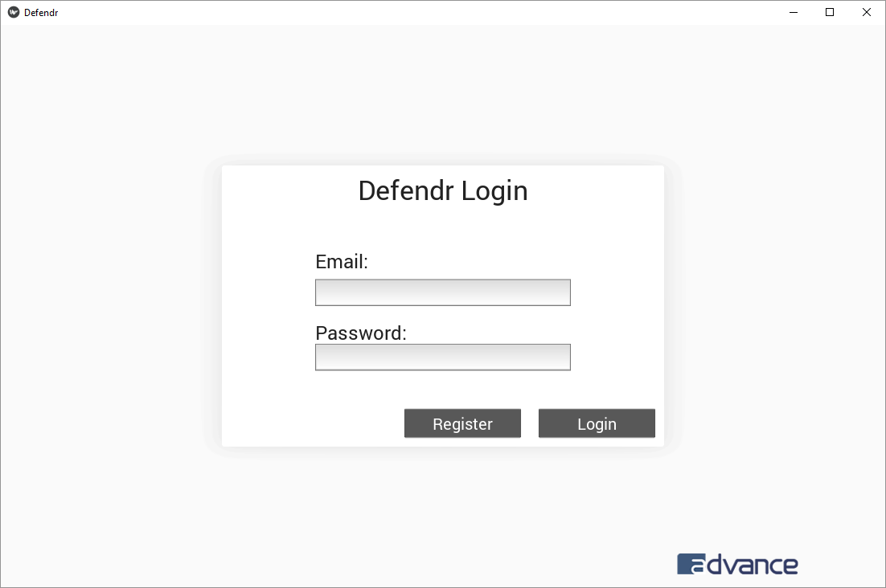

After the program installs, this window will appear on the screen. First time users of the system must please click on the register button, to register as a user of the system, as explained in section 2.2. Otherwise, log in with your credentials.

* 1. Registering

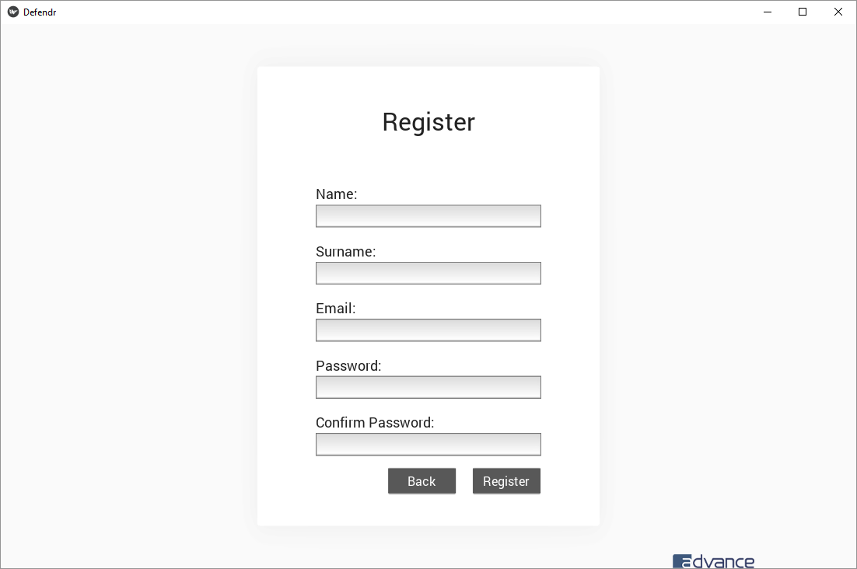

This window is for registering new users on the system. A user will be requested to fill in:

* His/her name
* Surname
* A valid E-mail address
* A Password
* Confirm password.

Please note that the password must contain:

* An uppercase character
* A lowercase character
* A symbol
* A number
* Must be at least six characters long.

After the user has completed their details, they will have to click on the register button. This will register the user by default as a new user, unless they are the first user on the system. If they are the first user on the system they will be registered as an admin user. Note that a new user can only sign in, after an admin user has verified their account. Once registration is successful, the user will be directed to the sign in screen. The back button will return the user to the sign in window.

# Using the System

* 1. Exploring the home window

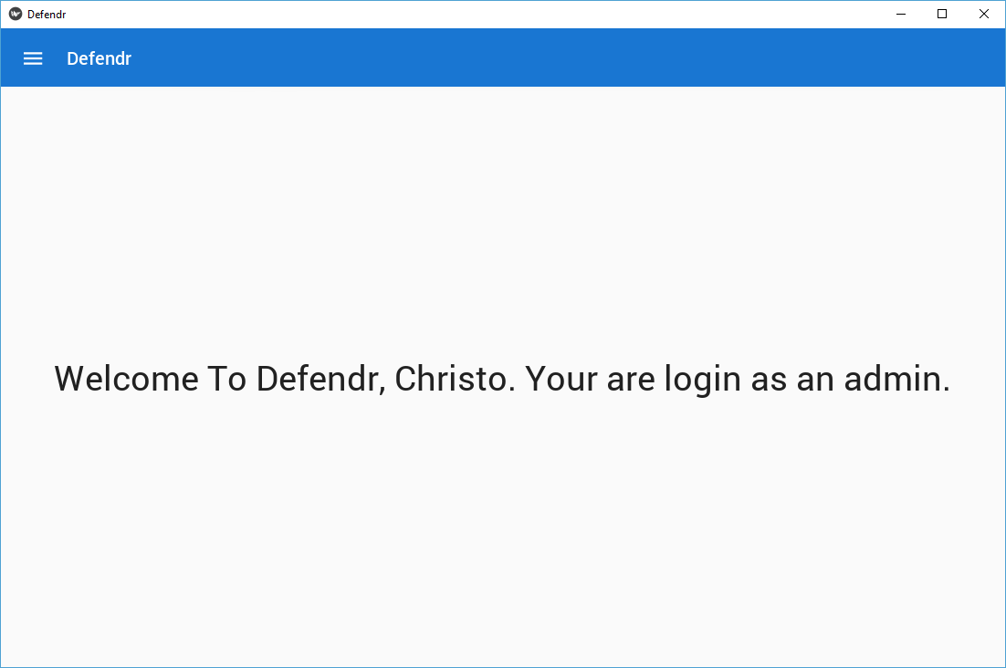

After successfully signing in as described in section 2*,* the home window will open. This is the window where the user can see under which account they are logged in, the permission that this account has and can navigate to the nav bar, by clicking on the menu button in the top left corner of the screen. (See section 3.2 for more on the nav bar.)

* 1. **Nav bar**

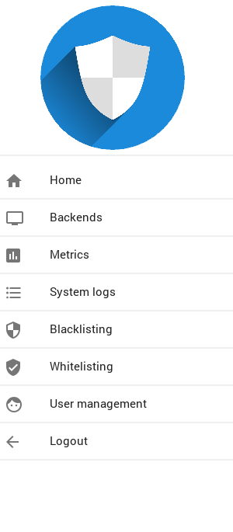

The Nav bar consists of eight buttons, which are described below. The Nav bar can be accessed from any window, by clicking on the menu button in the top left corner, except on the register- or sign in windows.

How to navigate this using the Nav bar:

* Home window: Click on the button that reads home with a home icon,
* Backends window: Click on the button that reads backends with a monitor icon,
* Metrics window: Click on the button that reads metrics with a bar graph icon,
* System logs window: Click on the button that reads system logs with a bullet list icon,
* Blacklisting window: Click on the button that reads blacklisting with a checkered shield icon,
* Whitelisting window: Click on the button that reads whitelisting with a shield with a tick icon,
* User management window: Click on the button that reads user management with a face icon,
* To Log out of the system, click on the logout button. This will return you to the sign in window.
  1. User Management

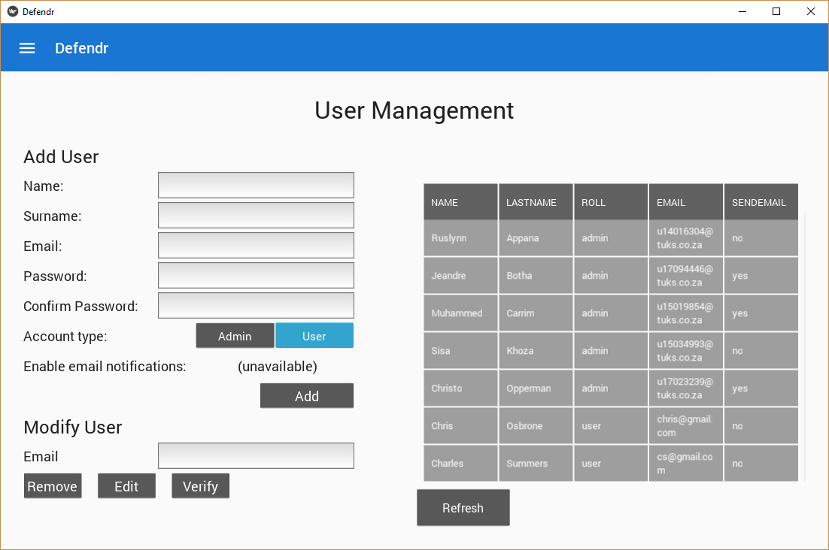

The user management plane has five main functions:

1. Adding new users.
2. Removing users.
3. Changing a user’s details.
4. Displaying all users.
5. Verifying new users.

* **To display all registered users,** click the refresh button. Note that the users will automatically be displayed, when the window is opened.
* **To add a new user,** fill in the details as mentioned in in Section 2.2 and then click on the Add button to complete the adding process. Note that you can select the role that the new user will have, by clicking on the admin or user button. If the new account is an admin user, the user will have the choice to be notified via e-mail of DOS attacks, new users being registered and blacklisting op IP’s.
* **To remove a user,** provide the e-mail address of the user that needs to be removed in the Email field under the Modify User heading and click the Remove button.
* **To change a user’s details**, insert the e-mail address of the user that needs to be changed in the Email field under the Modify User heading and click on the edit button which will open the change user window.
* **To verify a user,** provide the e-mail address of the user that needs to be verified in the Email field under the Modify User heading and click the Verify button.
  1. Changing user details

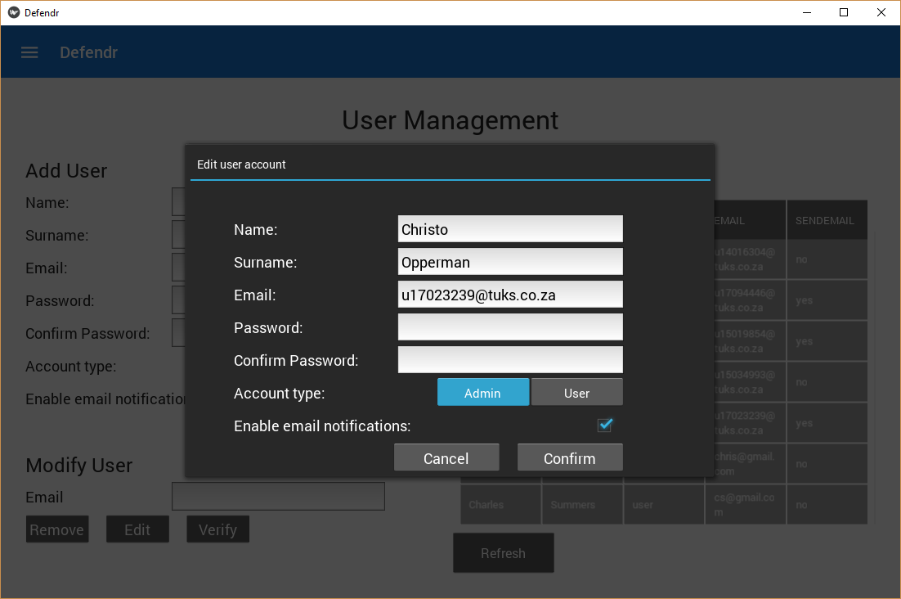

This window allows the user to change specific details for user accounts, such as name, surname, e-mail address, password and the role of the user.

* **To change user detail,** change the appropriate field and click the confirm button. Note that for security reasons, the password will not be completed and thus the user needs to supply the new password and will then have to confirm the new password.(See section 2.2 for password specifications.)
* **To return to the user management plane,** click the Cancel button
  1. IP blacklisting

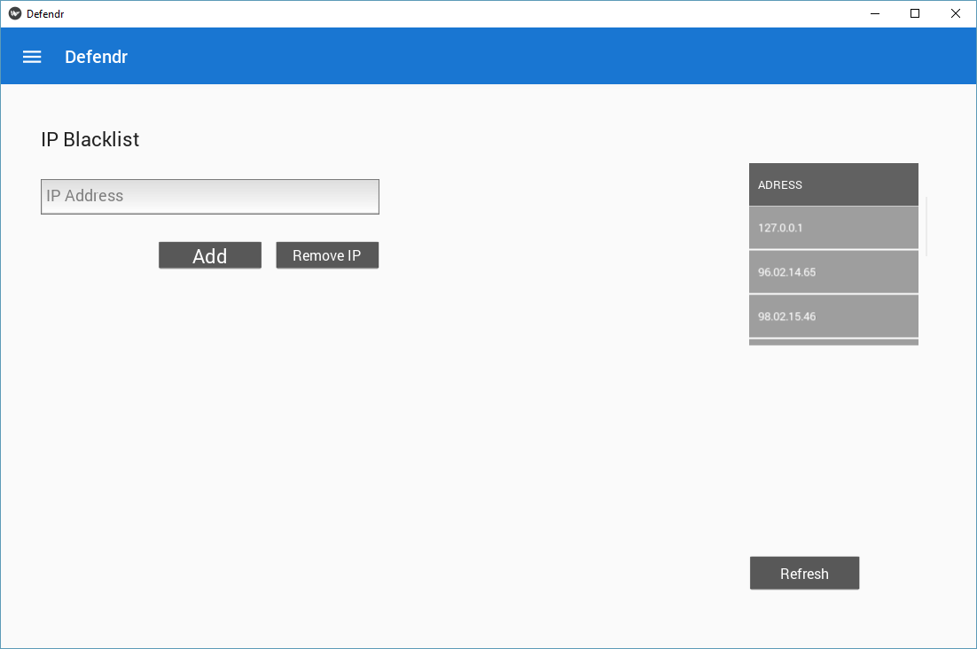

* **To manually blacklist an IP address,** enter the valid IP version 4 address to be blacklisted in the field, which is under the heading, IP Blacklist, then click on Add IP.
* **To remove a blacklisted IP address,** enter the valid IP version 4 address to be removed from the blacklisted IP addresses in the field, which is under the heading IP Blacklist, then click on Remove IP.
* **To view currently blacklisted IP addresses,** click the refresh button. Note that the blacklisted IP’s addresses will automatically be displayed, when the window is opened.
  1. IP Whitelisting

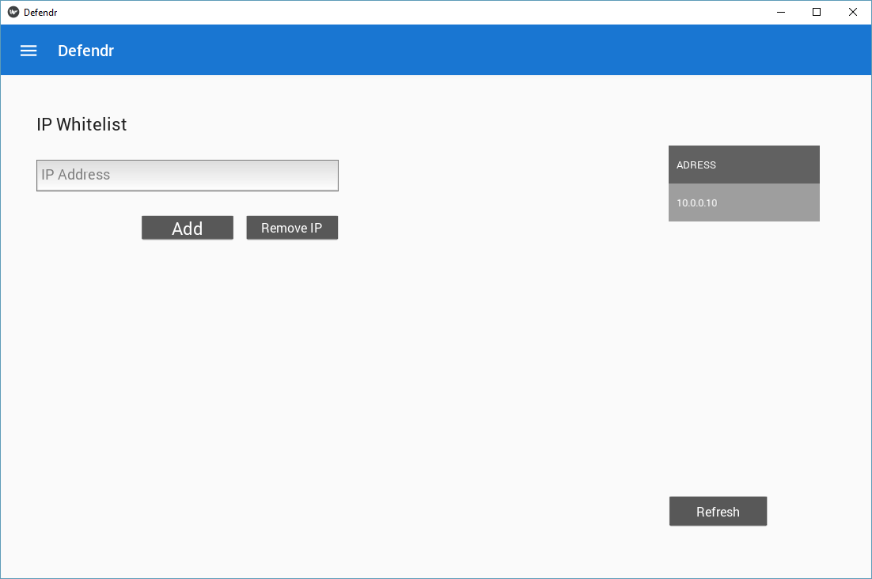

* **To manually w**hite**list an IP address,** enter the valid IP version 4 address to be whitelisted in the field, which is under the heading, IP Whitelist, then click on Add IP.
* **To remove a w**hite**list IP address,** enter the valid IP version 4 address to be removed from the whitelisted IP addresses in the field, which is under the heading IP whitelist, then click on Remove IP.
* **To view currently w**hite**list IP addresses,** click the refresh button. Note that the whitelisted IP’s addresses will automatically be displayed, when the window is opened.
  1. Viewing traffic logs

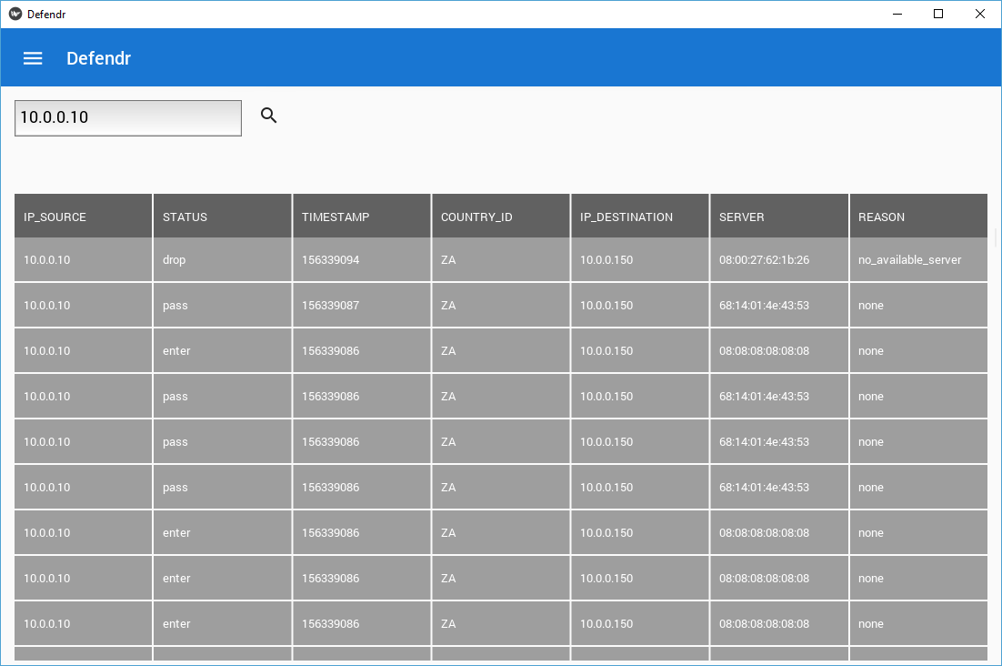

This window enables the user to see either all the packets that went through the system or packets for specific IP addresses.

* **To view all incoming packets,** leave the search field empty and click the magnifying glass icon.
* **To view packets with a specific source IP address,** enter the desired IP address in the search field and click on the magnifying glass icon.

* 1. Viewing System metrics

The metrics window has jurisdiction over system load and individual resource monitoring.

### Sign-in

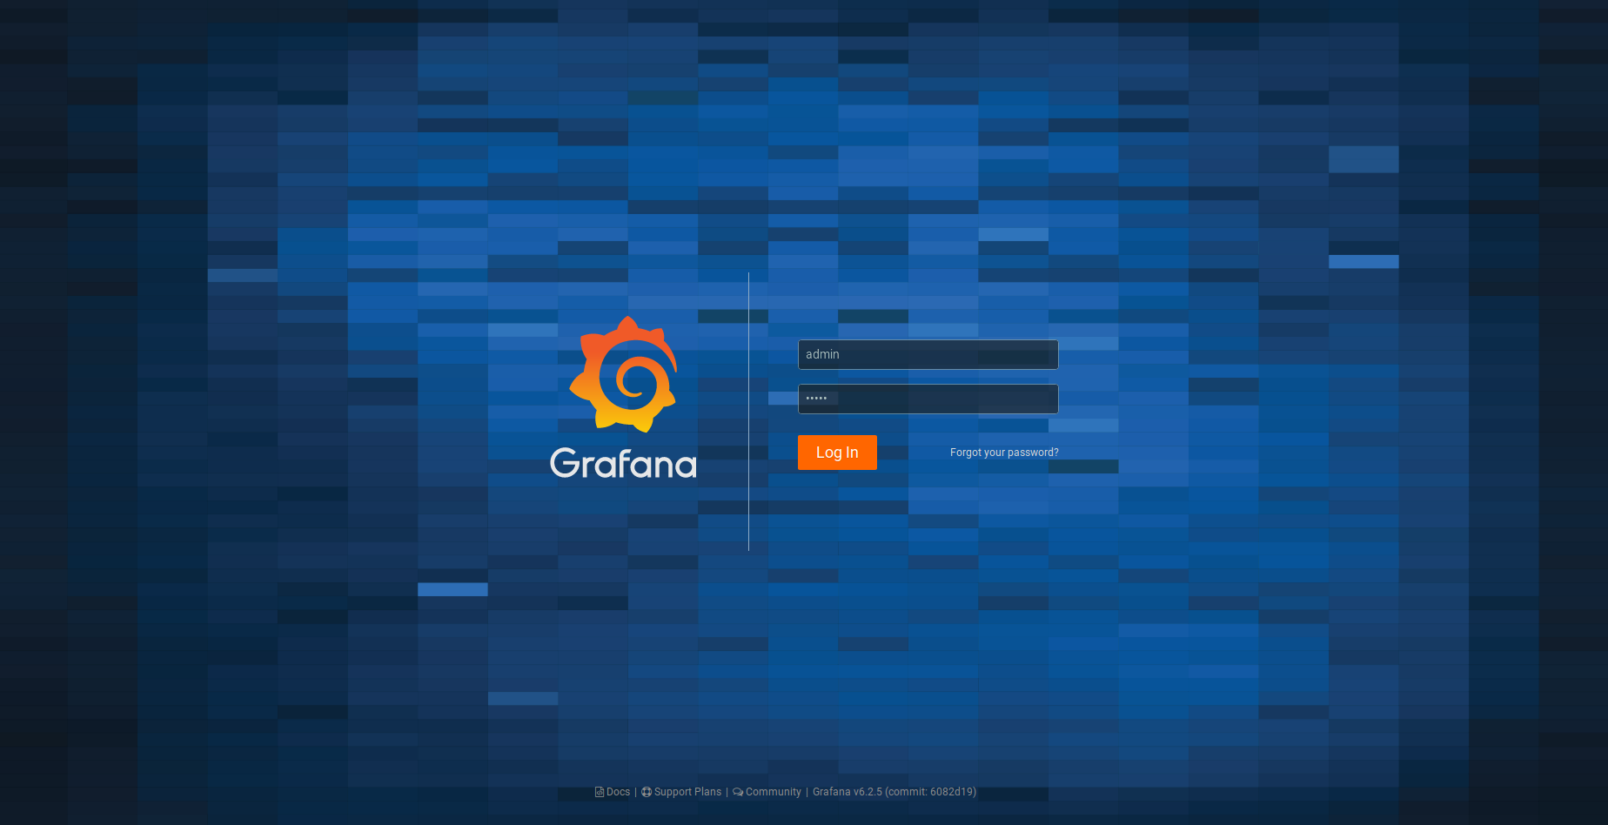

On click of the Metrics button (as shown in Section 3.1) a Grafana sign-in page will open in a browser. The default username is ***admin***,and the default password is ***admin***. You will be prompted to provide a more secure password at the first successful sign-in.

### Home Dashboard

B

D

C

E

F

A

G

The dashboard is a centralised portal to access metrics and configuration:

1. Create > Dashboard, Folder, Import
2. Dashboards > Home, Manage, Playlists, Snapshots
3. Explore
4. Alerting > Alert Rules, Notifications Channels
5. Configuration > Data Sources, Users, Teams, Plugins, Preferences, API Keys
6. Server Admin > Users, Orgs, Settings, Stats
7. Dashboards

### **- A) New dashboard**

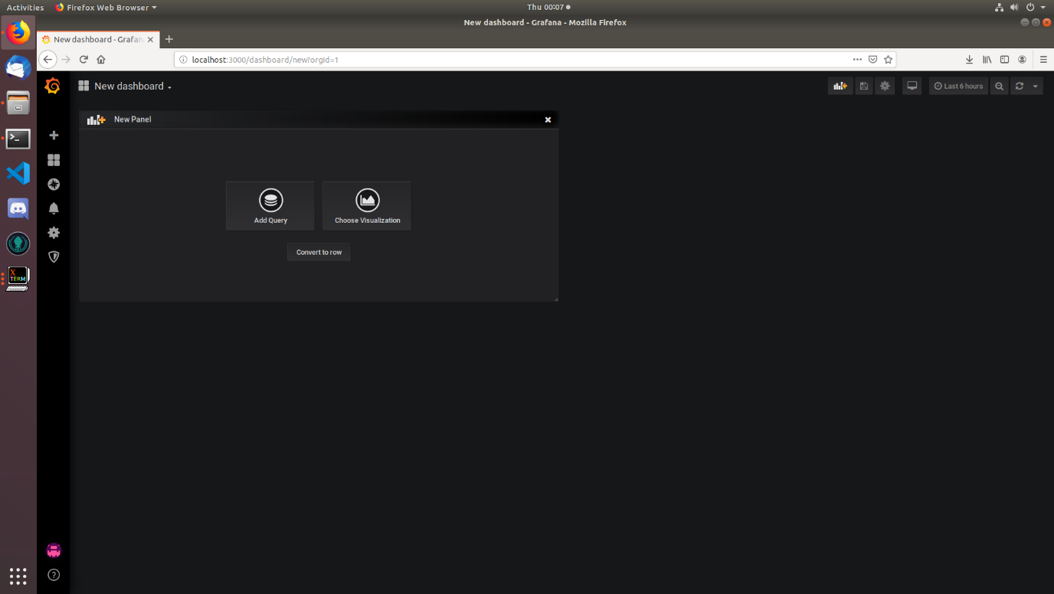

The **New Dashboard** page allows a user to create and customise a new dashboard. It also allows the querying of data from a data source.

### **- C) Explore**

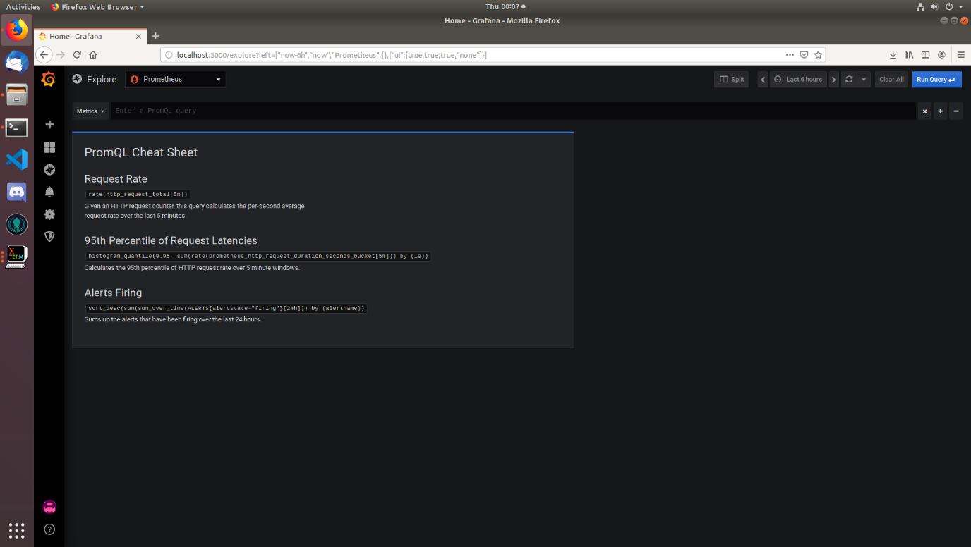

**Explore** is an information hub that give a user tips to better benefit from Grafana.

* + 1. - D) Alerting

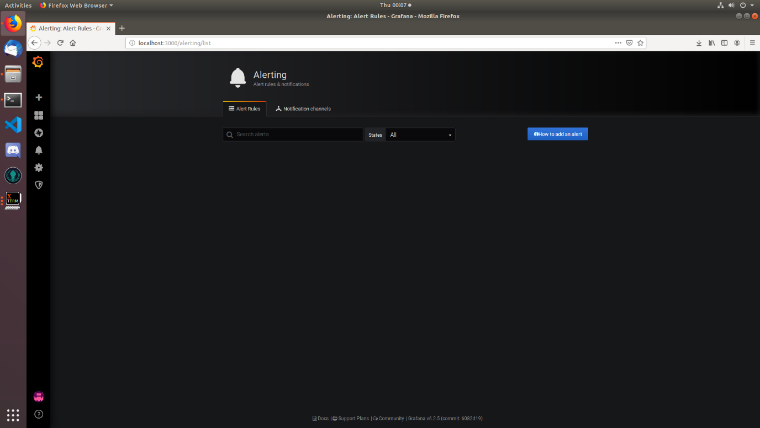

**Alerting** is a featured provided by Grafana to allow real-time updates to another communication channel, e.g. e-mail, Slack, Webhook etc., based on rules attached to a dashboard. One such example could be when the system is under a greater-than-normal network load.

### **- E) Configuration**

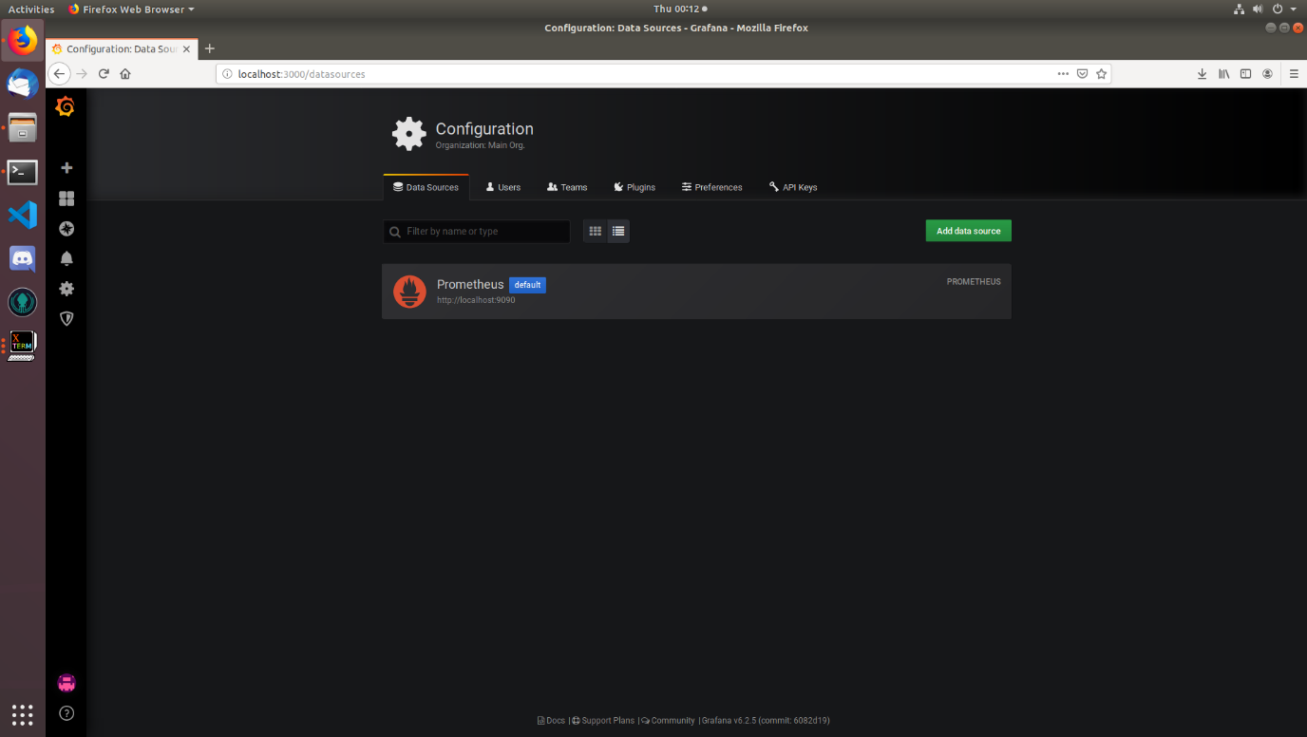

The **Configuration** page allows a user to add and remove other metrics reporting systems that Grafana can gather data from to graph. At current Prometheus will be visible by default.

### **- F) Server Admin**

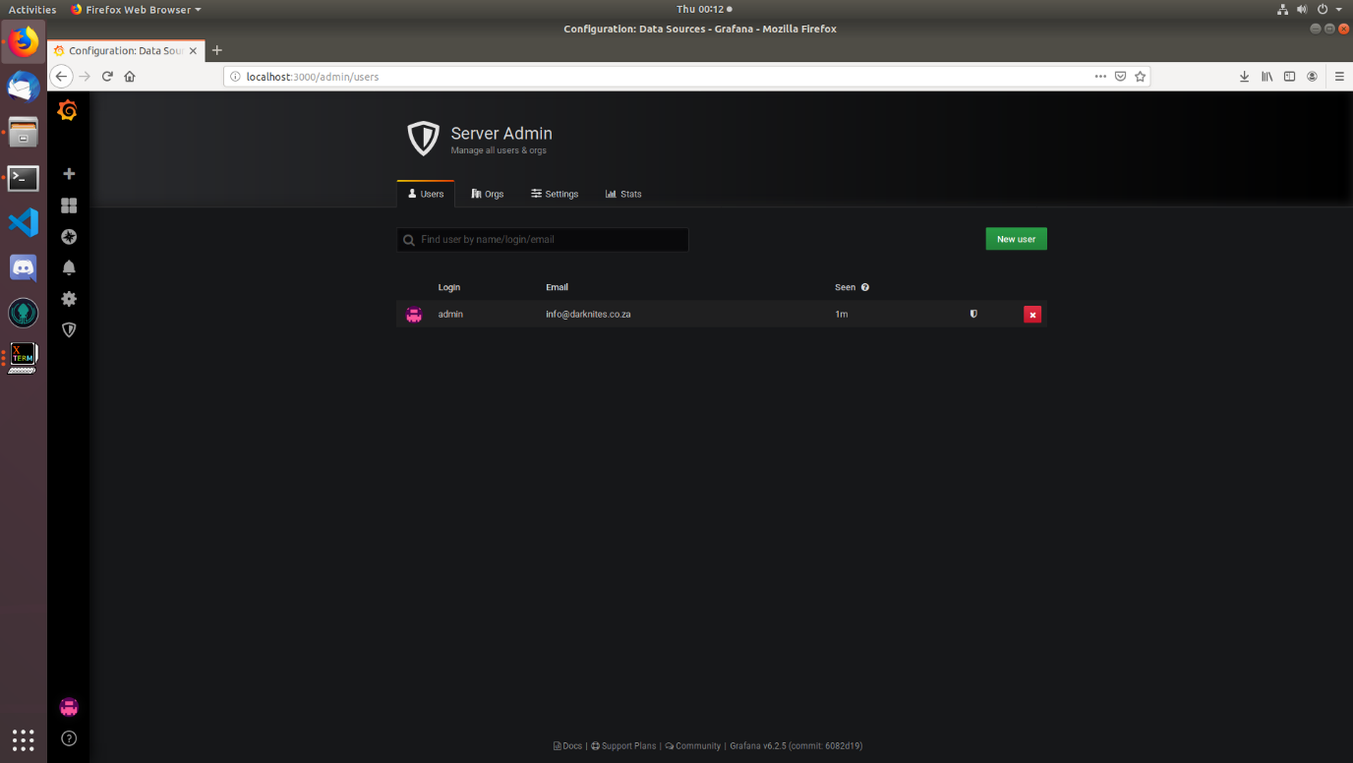

**Server Admin** is a page to carry out administrative tasks on Grafana. The system administrator will be able to

* create or remove users
* establish organisations (user privileges)
* change settings view Grafana logs.

### **- G) Defendr – System Load**

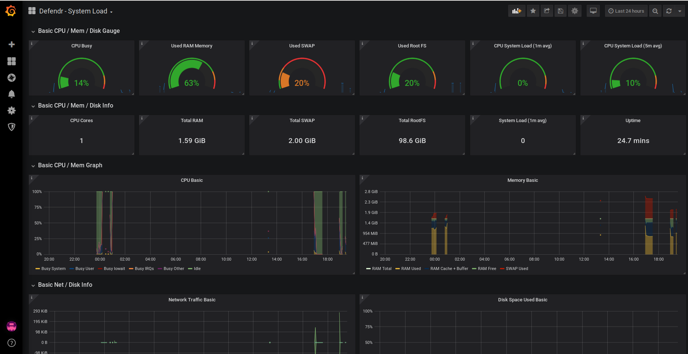

This window is the ***Defendr -System Load.*** This page will display the hardware-related usage statistics as provided by Prometheus and its exporters. This enables a unified monitoring tool for system load statistics.



### **- G) Defendr – Software Load**

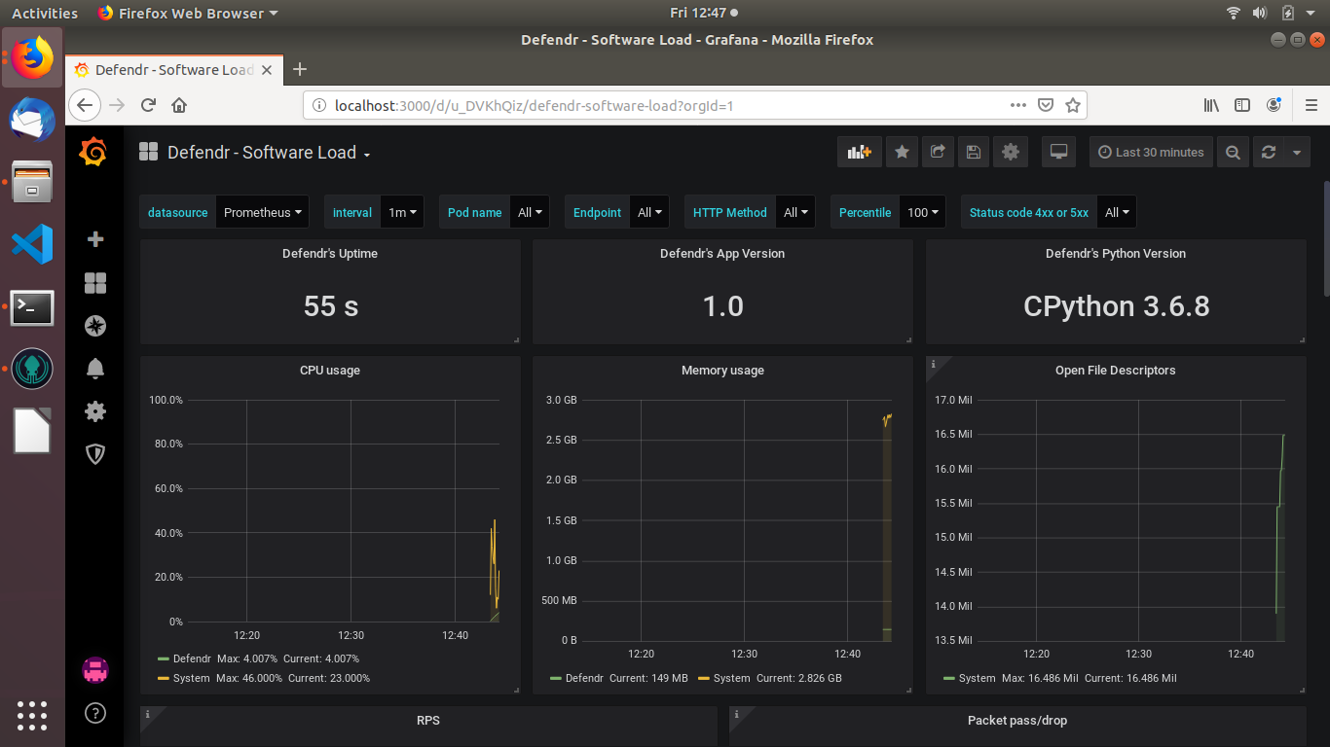

This window is the ***Defendr -Software Load.*** This page will display software-related metrics such as software version, uptime and software-related usage statistics. The rate of packets and connections is also displayed, alongside a heatmap.

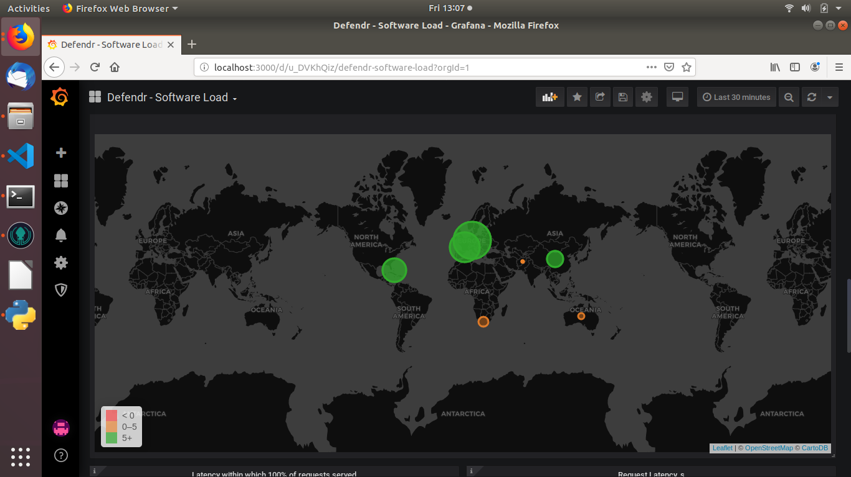

* 1. Backends and Load balancing

### **Backends Interface**

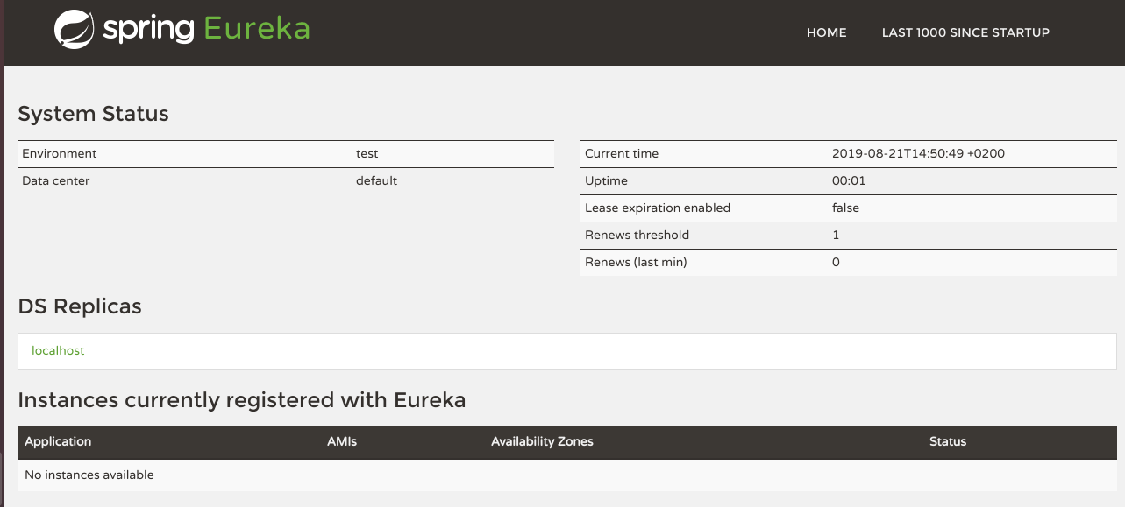

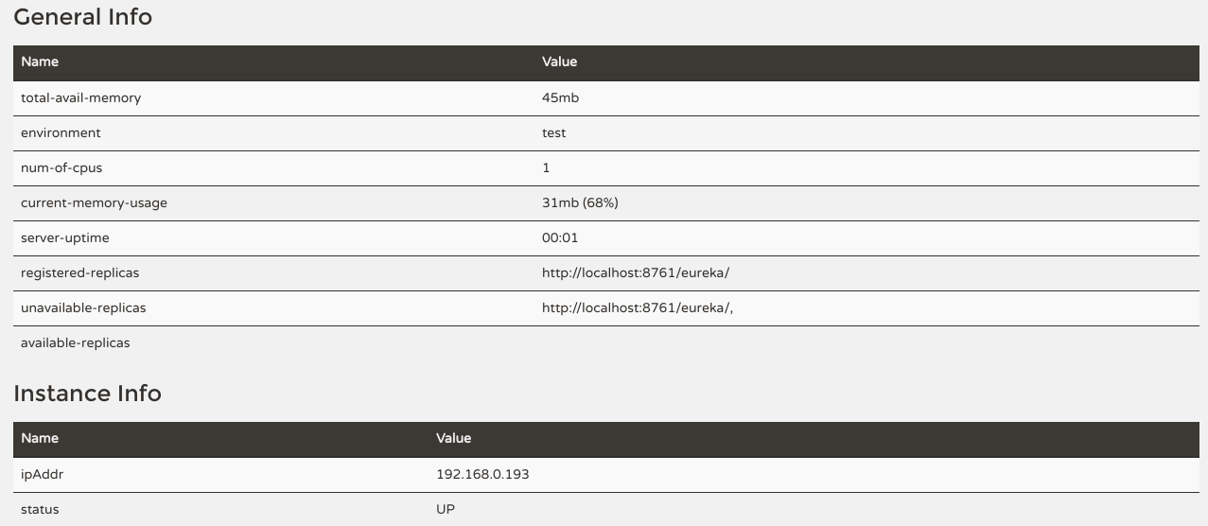

Load balancing will automatically start, when the Defendr application is running. The backend window is divided into five parts, namely:

* System status: This section supplies information about the system as a whole, such as the up time and the renews threshold rate.
* DS Replicas: Contains list of all duplicated Discovery server instances. On default the discovery server will only run locally on the Defendr server.
* Instances currently registered with Eureka: This represents all the backends that are registered on the system, as well as their status.
* General Info: This supplies more information about the system as a whole, such as the total available memory and registered replicas.
* Instance Info: This supplies IP addresses of the backends that are registered on the system.

### **Preparig service backends**

1. Open the system command line terminal on the desired machine. (This can be achieved by pressing Ctrl+Alt+T)
2. (Optional: skip this step and go to step 3 if arptables in already installed) Run The following commonad in the open command line terminal:

sudo apt-get install arptables

1. Enter the following commands in sequesnce.

* sudo arptables –A INPUT <virtual-service-ip> -j DROP
* sudo arptables –A OUTPUT <virtual-service-ip> -j mangle –mangle-ip-s <backend-real-ip>
* sudo ip addr add <virtual-service-ip> dev <network-device>

### **Adding service backends**

To add a new backend:

1. Start up the desired machine that contains the service instance.
2. Copy the “serviceInstance” folder from the downloaded Defendr package to any location on the machine.
3. Open navigate to serviceInstance/src/main/recources/
4. Open the file application.properties.
5. Change the property “app.name” to the applications ip address.
6. Change the property “client.instance_id” to the machine’s own ip address.
7. Return to the “serviceInstance” root folder : serviceInstance/
8. Open the command line terminal in this location. (right click in the folder and click on “Open Terminal Here”)
9. In the command line terminal type “gradle clean build” without the quotations and press enter.
10. After the build finishes, in the terminal, type “java –jar build/libs/serviceInstance.jar” without quotations and press enter.
11. The backend will now automatically register itself with the Defendr application.

# Troubleshooting

* 1. Missing bpf maps

In the unlikely event that the following error appears in a pop up terminal while opening the Defendr application



Mount the bpf file system by entering the command “sudo mount -t bpf bpf /sys/fs/bpf/” without the quotations within the terminal and press enter. If confronted with a request for the user password, enter the server password obtained from the server admin and press enter. The application can now be safely restarted.

In the event that the system interface becomes unresponsive the interface can simply be closed without doing any harm and restarted. This will not affect the system in any way.

* 1. Grafana is not showing any data

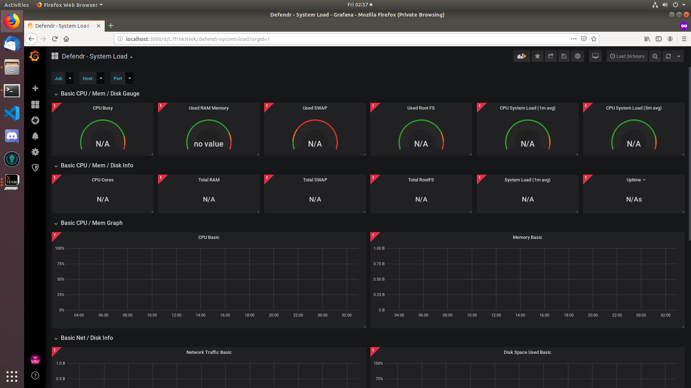At time an improper start-up of a server may cause a disruption in the proper display of metrics. This may be due to delays or disruptions in service start-ups. A Defendr restart may cause the system to return to normal functionality, however for persistent cases more steps can be taken to investigate and remediate.

To determine the cause, open a browser and navigate to:

* <http://localhost:9190>*
* http://localhost:9090*
* <http://localhost:3000>*

*curl <address> can be used in terminal as well

If no response is received, please try the following:

* Open a terminal in “/Defendr/src/Interfaces/Metrics”. This is the working directory and all the following commands, unless otherwise stated, will start here.

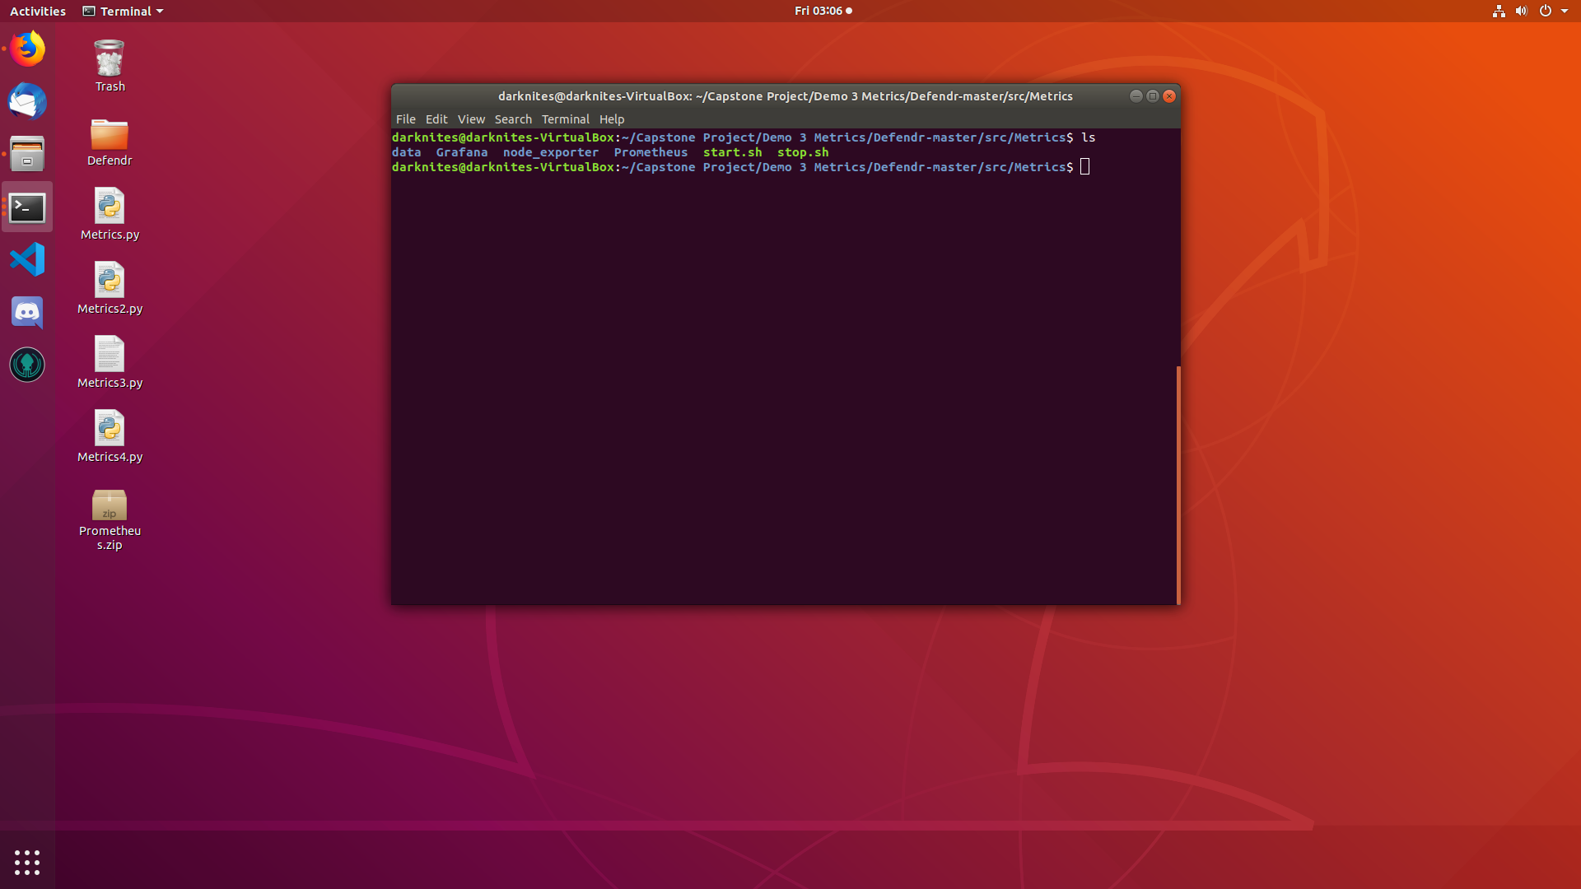

* Enter “./stop.sh”. Any rouge servers will stop. If a no process message appears, that just means the particular service was not running. 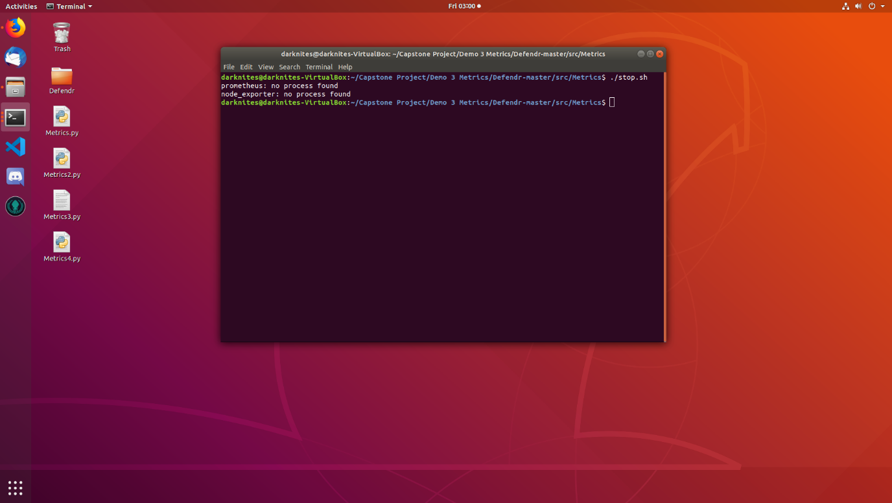
* Open a terminal and enter “./node_exporter/node_exporter”. Allow 5 seconds.

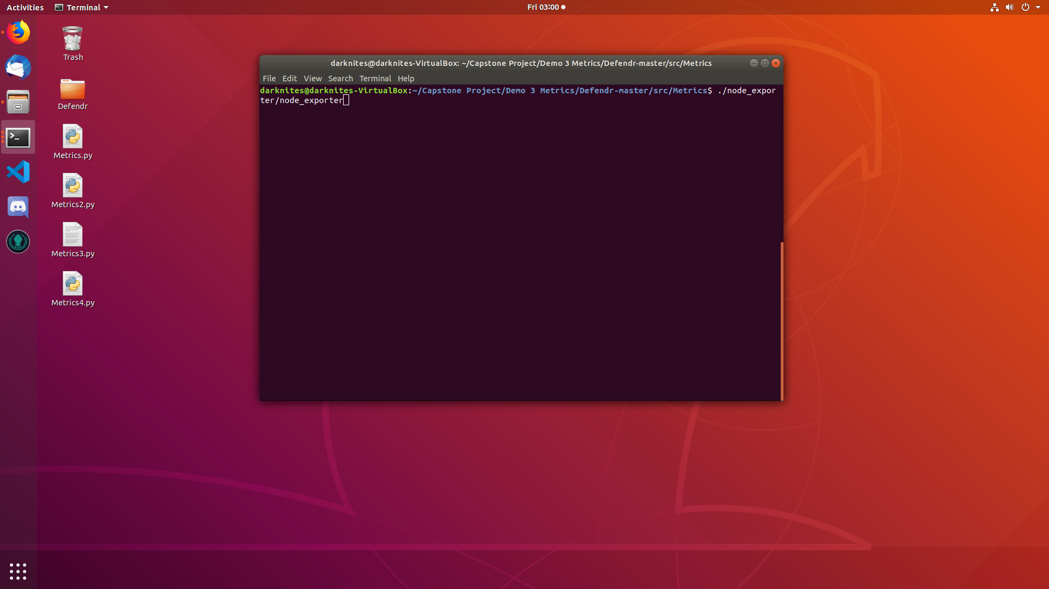

* Open a terminal and enter “cd Prometheus”. Then enter “./prometheus”. Allow 5 seconds.

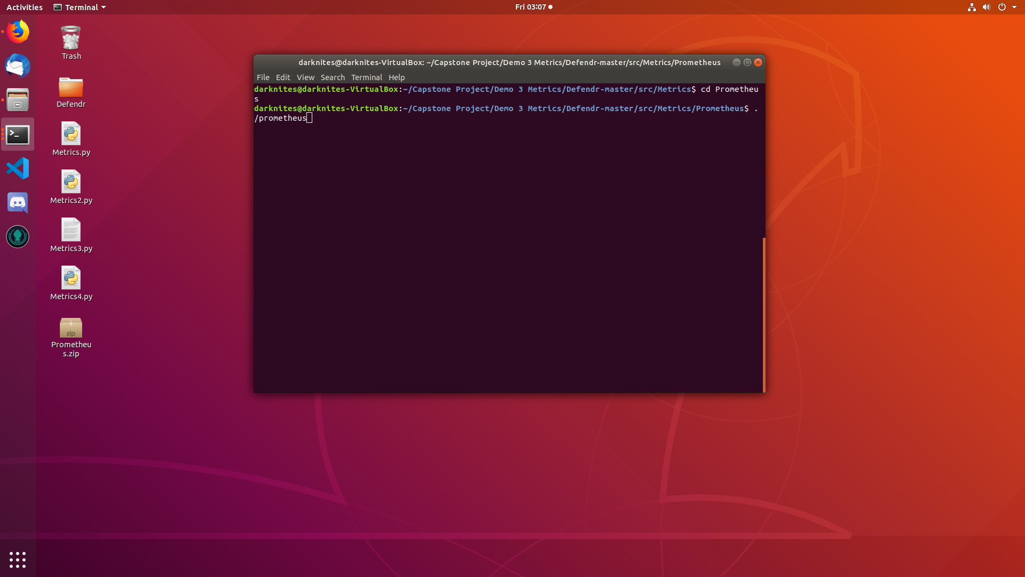

* Open a terminal and enter “cd Grafana/bin”. Then enter “./grafana-server”. Allow 5 seconds. 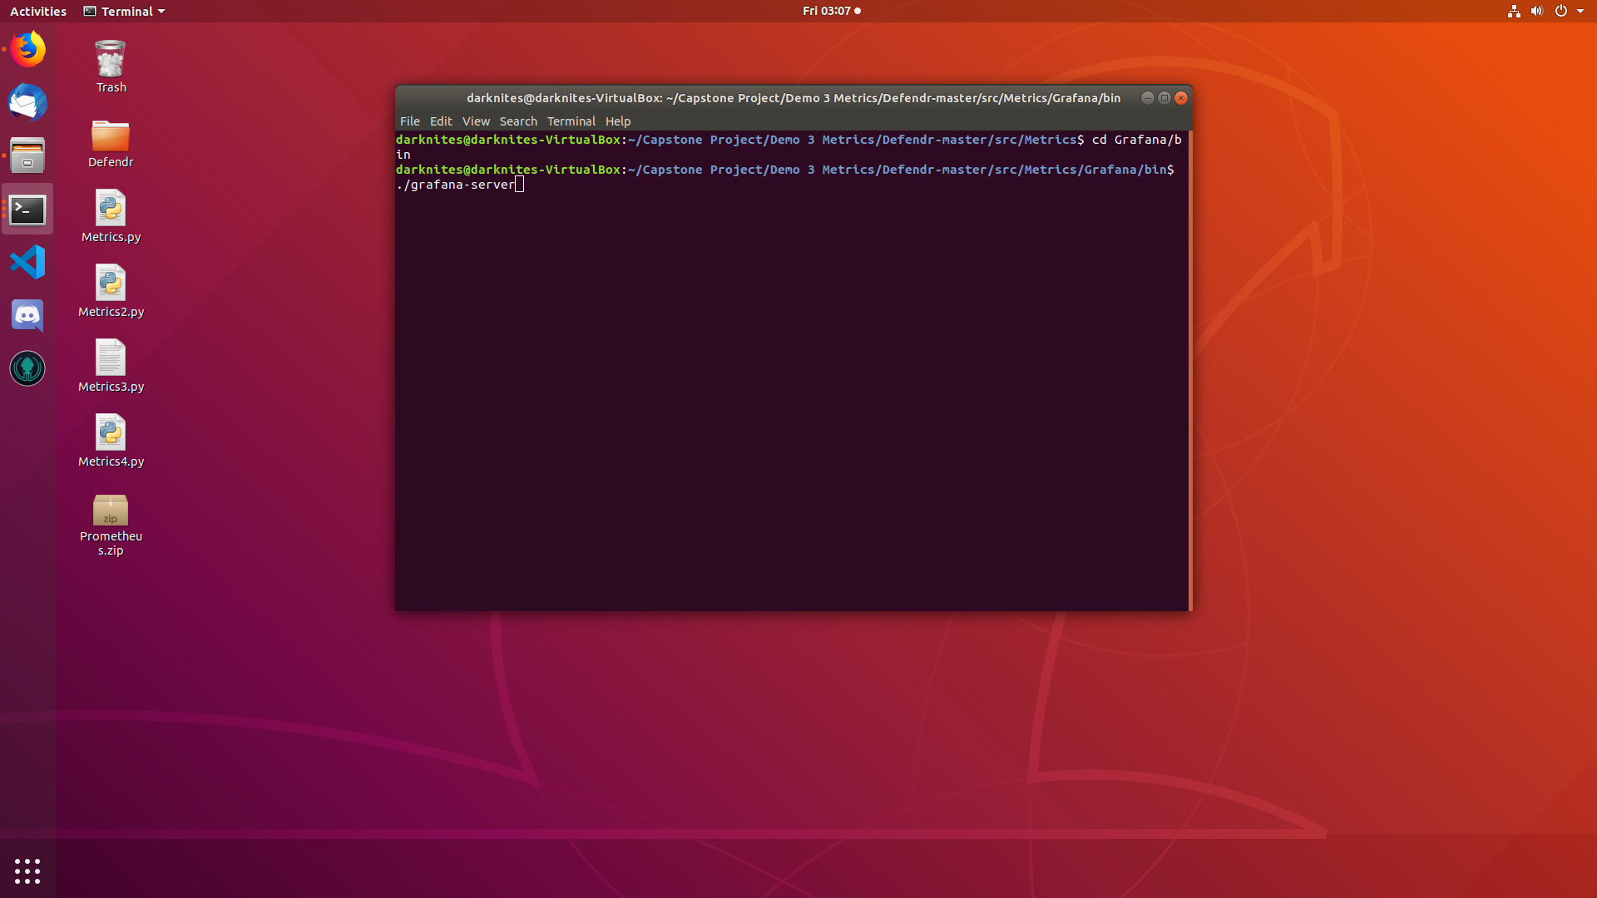
* Open a browser, and navigate to “<http://localhost:3000>”



Provided the above services started with no errors, Grafana log-in should be displayed and metrics accessible again.

* 1. Interface failures

### **Failure to Sign in**

If the system fails to sign in, make sure that the computer is connected to the Internet.

If the user has newly registered, the user should request admin to verify the account. Note that a user only receives three attempts to enter the correct password and e-mail address. After this an e-mail will be sent to the admin users and the user that tried to sign in will be forced to wait a minute.

### **Failure to open certain windows**

This can only be caused by the user not having sufficient permission. See table below for permissions.

|  |  |  |  |  |  |  |
| --- | --- | --- | --- | --- | --- | --- |
|  | **Windows** | | | | | |
|  | Backends | Metrics | System logs | Blacklisting | Whitelisting | User management |
| **Min permission needed** | User | User | User | Admin | Admin | Admin |

### **Failure to add IP address to black list:**

This can be due to three reasons, namely:

* An invalid IP version 4 address.(See <https://www.noip.com/support/knowledgebase/what-is-a-valid-ip-address/> for format of valid IP Addresses)
* The IP address has already been added.
* The IP address is in the White list and can thus not be blacklisted, before being removed from the White list.

### **Failure to add new User:**

This can be due to four reasons, namely:

* An invalid password. Sees section 2.2 for valid passwords specifications.
* An invalid email.
* Empty fields. Note that all fields needs to been filed in.
* A user with this email has already being registered.

**For further assisting please contact the developers at the following address:** *info@darknites.co.za*